PRACTICAL-2

AIM-TCP/UDP connectivity using Netstat

Task 1: Explain common netstat command parameters and outputs.

-Open a terminal window by clicking on Start | Run. Type cmd, and press OK.

-To display help information about the netstat command, use the /? options, as shown:

C:\> netstat /? <ENTER>

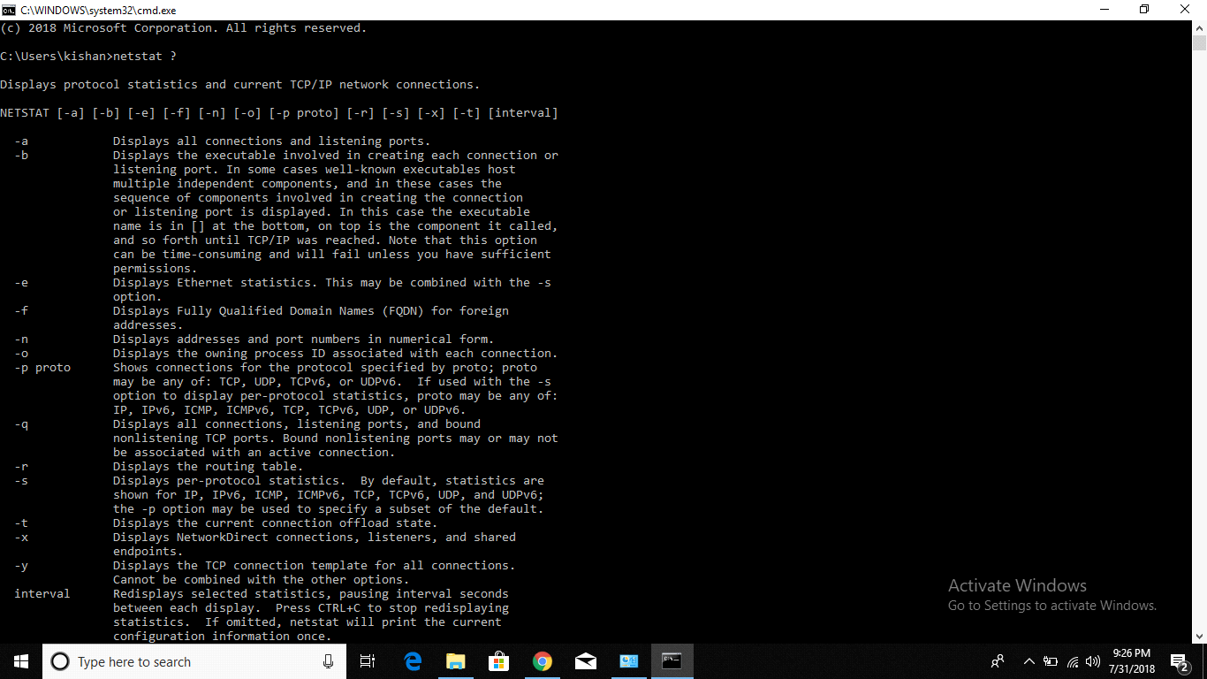

Step : Use netstat to view existing connections.

From the terminal window in Task 1, above, issue the command netstat –a:

C:\> netstat –a <ENTER>

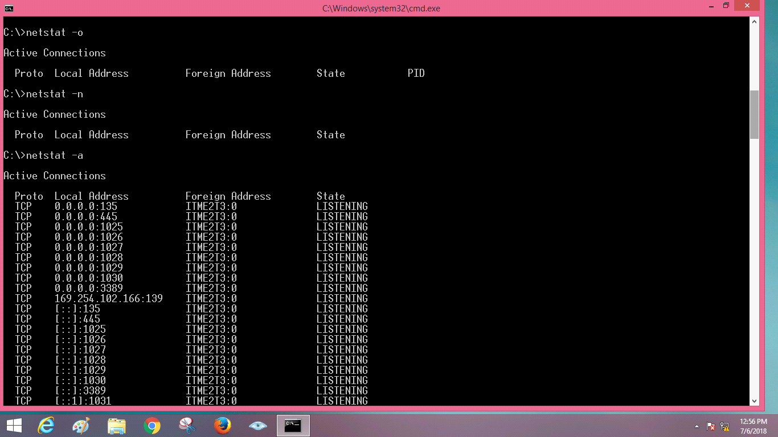

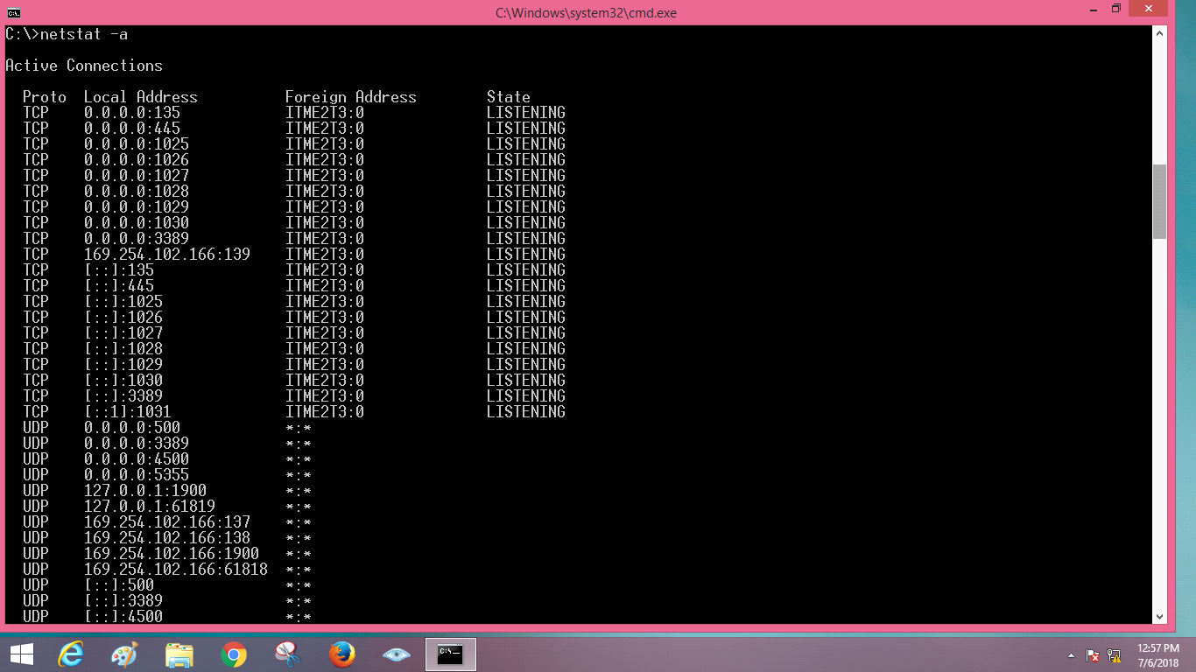

C:\> netstat –b <ENTER>

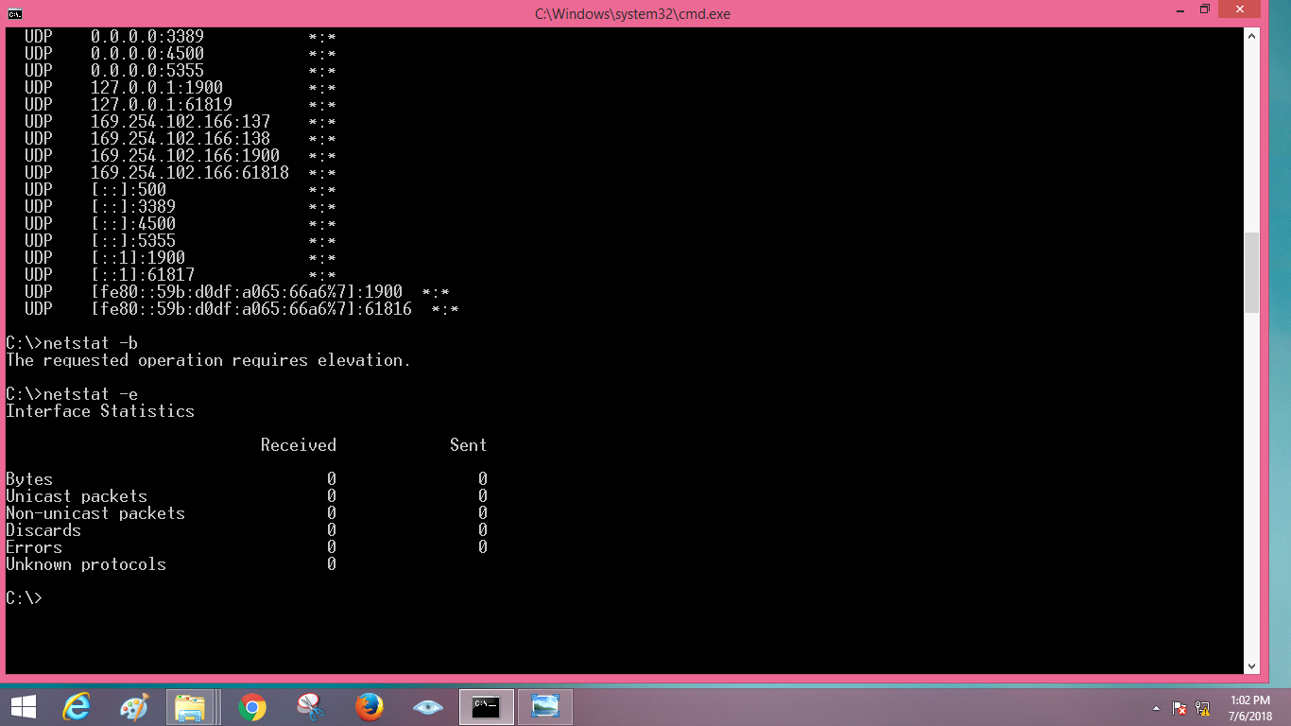

C:\> netstat –e <ENTER>

C:\> netstat –f<ENTER>

